

**Filming Permit Application Guide for Foreign Productions**

**2025**



**Contents**

1. *Introduction*
2. *Legal Basis*
3. *Application Requirements and Timeline*
4. *General Information*
5. *Responsibilities and Obligations of the Fixer*
6. *Responsibilities and Obligations of Foreign Producers*
7. *Key Considerations*
8. *Application Process*
9. *Evaluation of Applications*
10. *Contact Information*

***1.Introduction***

Foreign producers intending to conduct commercial filming in Türkiye are required to obtain a filming permit from the General Directorate of Cinema under the Ministry of Culture and Tourism of the Republic of Türkiye.

This guide has been prepared to provide foreign producers and local coordinators with a clear, accessible, and efficient explanation of the filming permit application process.

1. ***Legal Basis***

|  |  |
| --- | --- |
| ***Regulation Type*** | ***Description*** |
| ***Law*** | Law No. 5224 on the Evaluation, Classification, and Support of Cinema Films |
| ***Regulation*** | Regulation on Filming Permits |
| ***Other*** | Relevant legislations of governorates, municipalities, and law enforcement agencies |

1. ***Application Requirements and Timeline***

|  |  |
| --- | --- |
|  | ***Description*** |
| ***Eligible Applicant*** | Foreign producers seeking to conduct commercial filming in Türkiye. |
| ***Application Method*** | Online application via <https://filmingpermit.ktb.gov.tr> |
| ***Submission Deadline*** | At least 10 business days prior to the commencement of filming |

1. ***General Information***

* Filming permits for commercial foreign productions in Türkiye are issued by the General Directorate of Cinema.
* Applications must be submitted by the foreign producers themselves and completed at least 10 business days before filming begins.
* All required documents and information must be accurately and completely uploaded to the system. Applications with missing or incorrect data will not be processed.
* For projects that are continuations of previously approved ones, a new application must be submitted with all relevant documents re-uploaded, even if they were submitted previously.
* A Turkish version of the script and synopsis must be submitted both during the application and after the filming concludes.
* Film crews seeking visa information should contact the Turkish Embassy or Consulate in their home country.
* After the screening of the film/program, a copy or digital footage must be submitted to the General Directorate of Cinema.
* At least one Turkish citizen must be employed as a fixer for any foreign film production conducted in Türkiye.

1. ***Responsibilities and Obligations of the Fixer***

* Employing at least one Turkish citizen as a local coordinator is mandatory for all foreign productions filmed in Türkiye.
* The fixer must upload all required documents proving their eligibility to serve in this role.
* Following the completion of shooting, the fixer must submit an evaluation report in both Turkish and English to the General Directorate of Cinema within 15 days.

1. ***Responsibilities and Obligations of Foreign Producers***

* According to Article 13 of the Regulation on Filming Permits and Co-Productions, if the information and documents declared in the application are found to be ıncomplete or ıncorrect, the permit will be revoked, and filming activities will be halted.
* Producers must submit the digital footage to the General Directorate of Cinema within ten (10) days of the film's release using the most appropriate data carrier (external drive or online file-sharing platform).

Any discrepancy between the declared filming details and the actual practices, or any conduct causing reputational harm to Türkiye, may influence the evaluation of future applications.

1. ***Key Considerations***

***a.Work Permits and Visa Exemptions***

If the visa or visa-exempt period is less than 90 days, and filming is intended to exceed this period, or if foreign nationals wish to continue working after the 90-day limit without a residence permit, they must apply for a residence permit before the expiry of their current legal stay.

If the filming period exceeds the authorized duration, and the relevant authority approves an extension, the extension document must be presented to the Directorate General of Migration Management. It is crucial to allow sufficient time for this process before the initial permit expires.

***b. Drone Shooting***

Drone-related filming permit applications must be submitted to the Directorate General of Civil Aviation through diplomatic channels.

***c. Mapping and Navigation Updates***

Filming for map updates and navigation system work must be authorized by the relevant Governorates.

***d. Foreign Journalists and TV Correspondents***

Foreign journalists and radio/TV correspondents seeking to record audio and video for news programs must apply to the Directorate of Information under the Ministry of Foreign Affairs and the Directorate of Communications under the Presidency.

***e. Photography***

For photography-only projects, photographers or teams must apply directly to the Provincial Directorate of Culture and Tourism.

***f. Filming in Military Areas***

Filming and recording in military zones is strictly prohibited.

1. ***Application Process***

* Applications are submitted online via <https://filmingpermit.ktb.gov.tr>
* Before applying, applicants must carefully read the information page and check all required declarations and undertakings.
* Applications cannot proceed unless the information page is acknowledged.

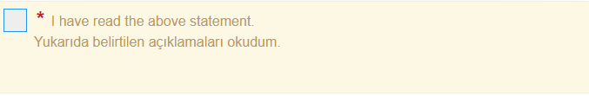

* Following the selection of the relevant field, the next step is to indicate the type of applicant.



Click on 'New Application Registration' to create a new user.

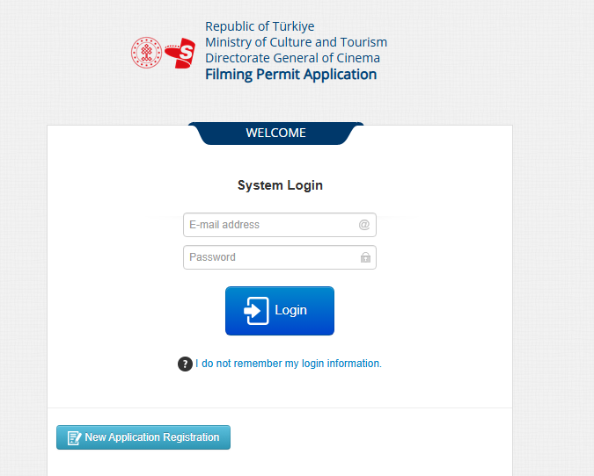

Fill in the information about the new user on the screen below and create a password to log in to the system.

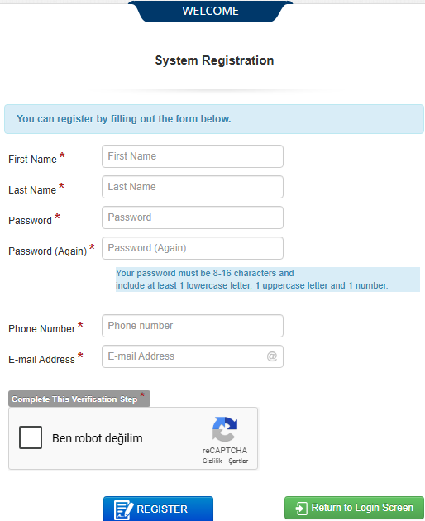

After logging into the system, access the new application from the “New” section on the left side of the screen.

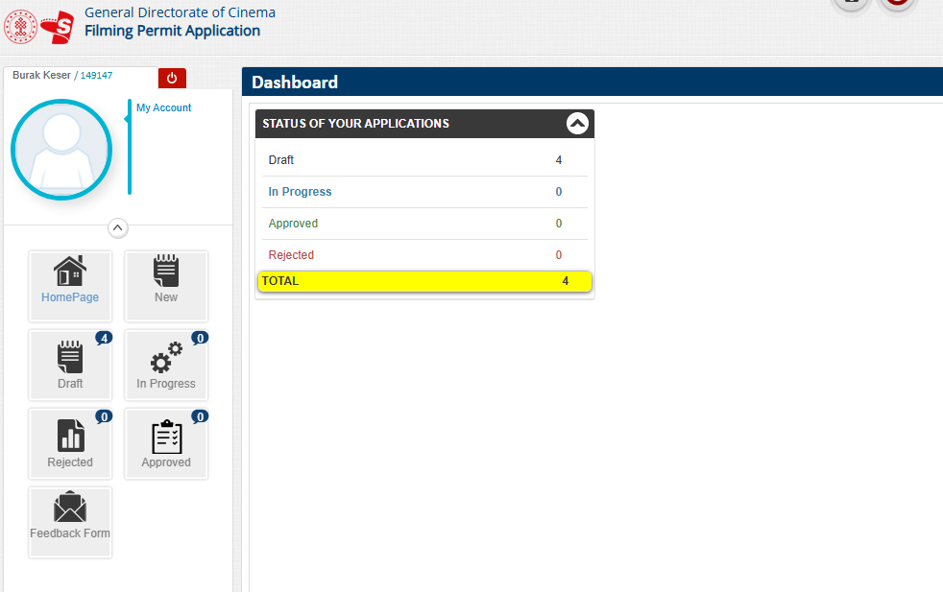

The applicant can view draft applications in the 'Draft' section on the left, applications still in progress in the 'In Progress' section, rejected applications in the 'Rejected' section and approved applications in the 'Approved' section.

When entering the “New” section, forms containing information about the producer, project information, team information, venue information, host, and, if applicable, executive producer information are filled out in sequence.

The producer's information is entered in the section below.

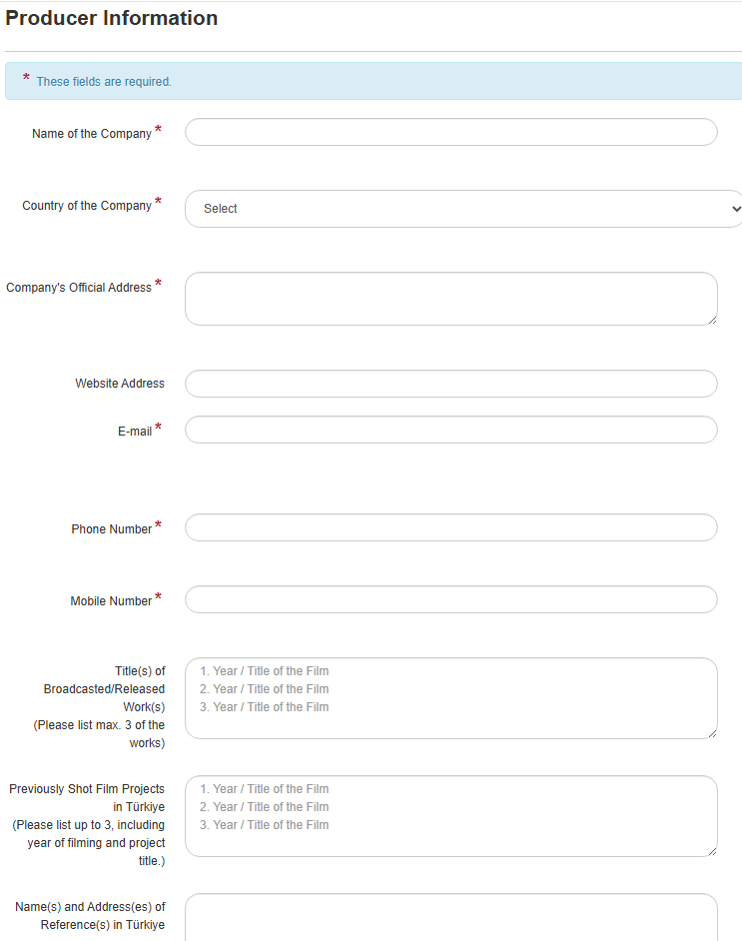

The section below the form is filled out with information about the project to be filmed.

### 

### 

The section below the form is filled out with information about the film equipment.

### 

### The province, district, street, and any other areas where the shoot will take place are written in full. For each new shooting location, the add button is pressed and the location information is added.

### 

### Information about the people in the team that will carry out the shoot and their passport images should be added to the section below. Applications for projects with missing passport information will not be accepted.

### 

At least one fixer who is a citizen of the Republic of Türkiye must be employed for foreign film shoots to be carried out in Türkiye. Information and documents relating to the fixer are recorded in the section below.

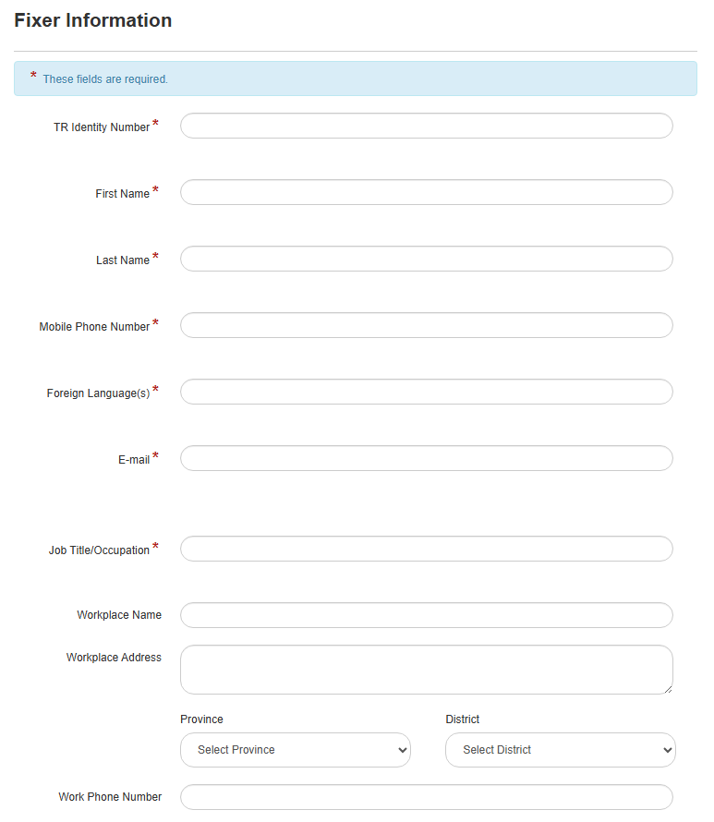

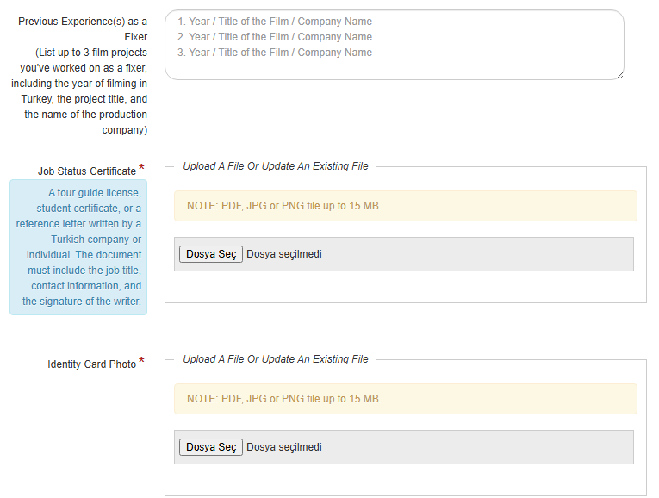

If there is an executive producer involved in the project, or if the fixer is also the executive producer, the following field must be filled in.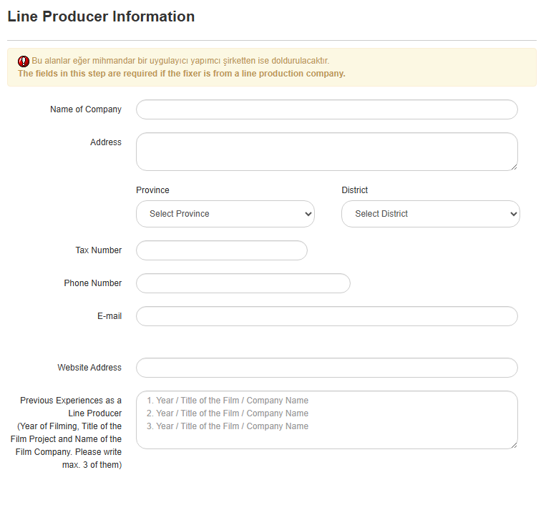

### When the form is filled out completely and correctly, the approval section is checked and the application is completed.

1. ***Evaluation of Applications***

* Completed applications are forwarded to the Foreign Filming Permit Application Management System of the General Directorate of Cinema.
* It is processed and reviewed by expert users through the Foreign Filming Permit Application Management System.
* Approved projects are granted a “General Filming Permit”.
* A company/institution/individual that has obtained a general filming permit from the General Directorate of Cinema of the Ministry of Culture and Tourism must also obtain permission from the highest administrative authority of the location where the filming will take place, or, in the case of locations requiring special permission, from the public institution or private organization to which that location is affiliated.
* For additional information and permission, applications should be made to the Provincial Culture and Tourism Directorates in the provinces where filming will take place. Therefore, it is recommended that all application documents for filming permission be submitted at least two weeks before the film crew enters Türkiye
* Additional permission from the General Directorate of Cultural Heritage and Museums is required for filming in cultural heritage sites.

***10.Contact Information***

Republic of Türkiye Ministry of Culture and Tourism

General Directorate of Cinema

Address: Anafartalar Cad. No: 65, Floor: 2, 06250 Ulus-Altındağ / ANKARA

Phone: +90 312 470 80 80

E-mail: bilgi.sinema@ktb.gov.tr